**Lab 6**

**Data Import**

a. Download northwind-db.sql from classroom link

b. Open MySQL Workbench and Login using root or <name>

c. Create database <name> northwindview

**Query:**

create database rajan_northwindview;

Output:

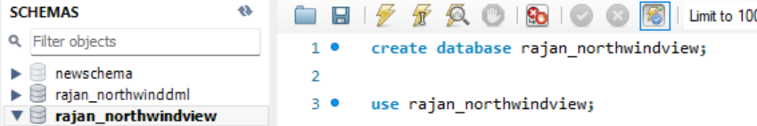

d.Import  downloaded database in <name>northwindview

**Output:**

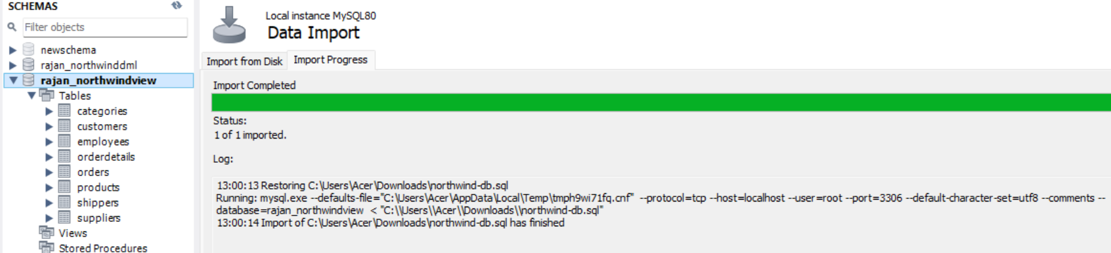

**Data MANIPULATION Languages (DML)**

1. Perform UNION of customers and employees relation. (i.e. only matching attributes)

**Query:**

SELECT CustomerID AS ID, CustomerName AS Name, ContactName AS Contact FROM customers

UNION

SELECT EmployeeID AS ID, FirstName + ' ' + LastName AS Name, '' AS Contact FROM employees;

**Output:**

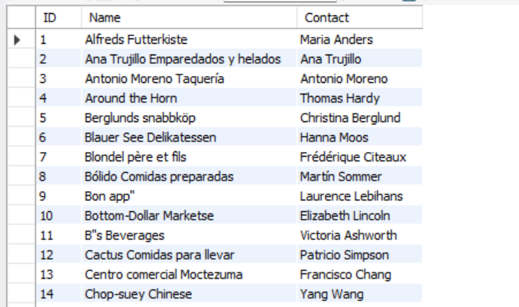

1. Perform UNION ALL of customers.contactname and employee.fullname

**Query:**

SELECT ContactName AS FullName FROM customers

**Output:**

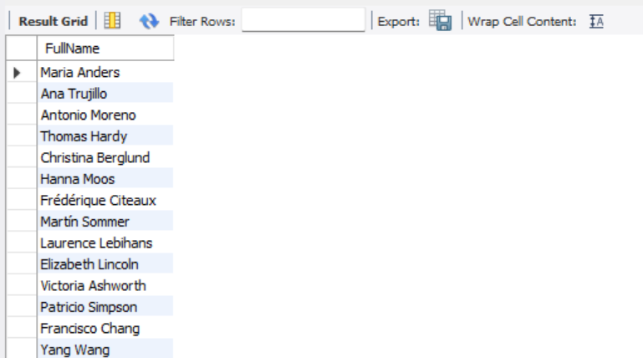

1. List all customers from Mexico and Austria using UNION

**Query:**

SELECT * FROM customers WHERe Country = 'Mexico'

UNION

SELECT * FROM customers WHERE Country = 'Aaustria';

**Output:**

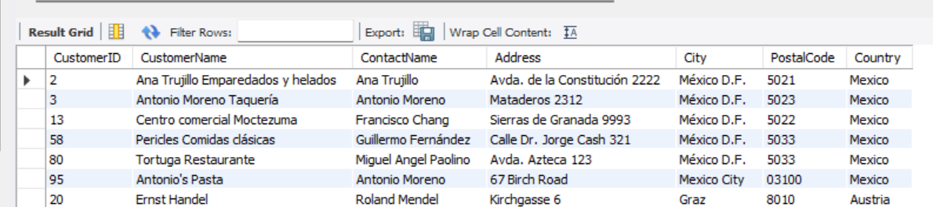

4.List all customers of USA not having same name as of customers from UK

**Query:**

SELECT * FROM customers

WHERE Country = 'USA'

AND CustomerName NOT IN (SELECT CustomerName FROM customers WHERE Country = 'UK');

**Output:**

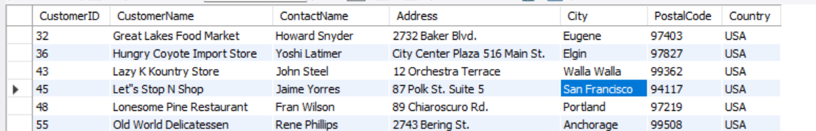

5.Create view cust by selecting only 4 attributes from customers

**Query:**

CREATE VIEW cust AS

SELECT CustomerID, CustomerName, City, Country FROM customers;

**Output:**

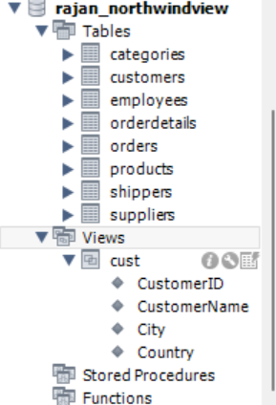

1. Join Products with Categories and Suppliers to create a view named **productinfo** with productID,Name,Unit, Price from products and all attributes from categories and suppliers

**Query:**

CREATE VIEW productinfo AS

SELECT p.ProductID, p.ProductName, p.Unit, p.Price,

c.CategoryID, c.CategoryName, c.Description,

s.SupplierID, s.SupplierName, s.ContactName, s.Address, s.City, s.PostalCode, s.Country, s.Phone

FROM products p

JOIN categories c ON p.CategoryID = c.CategoryID

JOIN suppliers s ON p.SupplierID = s.SupplierID;

**Output:**

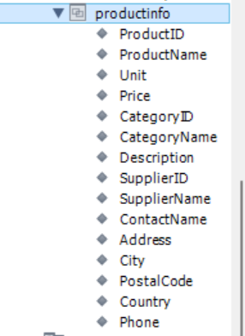

1. Find name and count of Categories from productinfo.

**Query:**

SELECT CategoryName, COUNT(*) AS ProductCount

FROM productinfo

GROUP BY CategoryName;

**Output:**

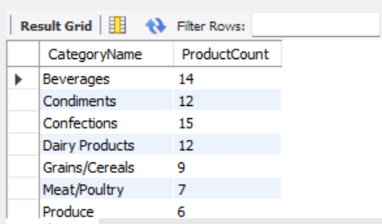

8.Find all products that have suppliers from North America in **productinfo**

**Query:**

SELECT * FROM productinfo

WHERE Country IN ('usa', 'canada', 'mexico', 'panama'); -- Add more north american countries as needed.

**Output:**

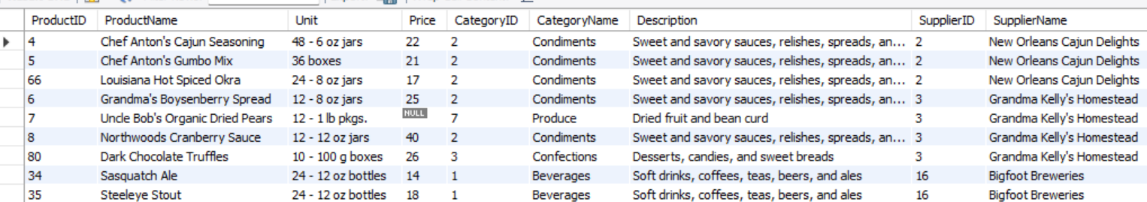

9.Find all products that have price lower price than Average price from **productinfo**

**Query:**

SELECT * FROM productinfo

WHERE Price < (SELECT AVG(Price) FROM productinfo);

**Output:**

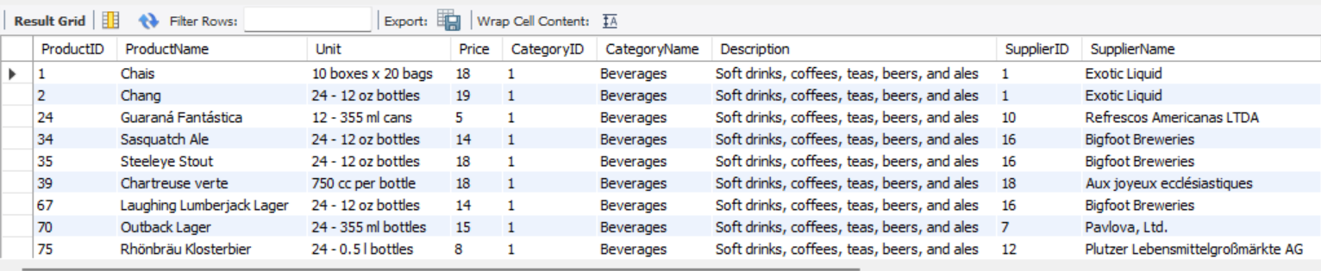

1. Join orders with customers, employees and shippers to create a view as **orderinfo**.

**Query:**

CREATE VIEW orderinfo AS

SELECT o.OrderID, o.OrderDate, c.CustomerName, e.FirstName + ' ' + e.LastName AS EmployeeName, s.ShipperName

FROM orders o

JOIN customers c ON o.CustomerID = c.CustomerID

JOIN employees e ON o.EmployeeID = e.EmployeeID

JOIN shippers s ON o.ShipperID = s.ShipperID;

**Output:**

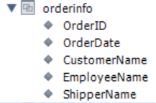

11.List all order shipment provided by United Package and Swift Shipping from **orderinfo**

**Query:**

SELECT * FROM orderinfo

WHERE ShipperName IN ('United Package', 'Swift Shipping');

**Output:**

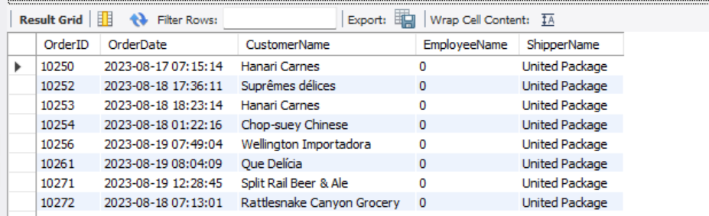

12.List all order processed by employee Janet Leverling and Steven Buchanan from **orderinfo**

**Query:**

SELECT * FROM orderinfo

WHERE EmployeeName IN ('Janet Leverling', 'Steven Buchanan');

**Output:**

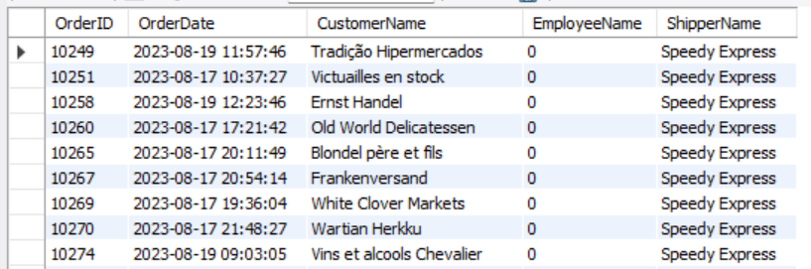

13.List all order shipment provider on date august 18 2023 from **orderinfo**

**Query:**

SELECT * FROM orderinfo

WHERE OrderDate = '2023-08-18';

**Output:**

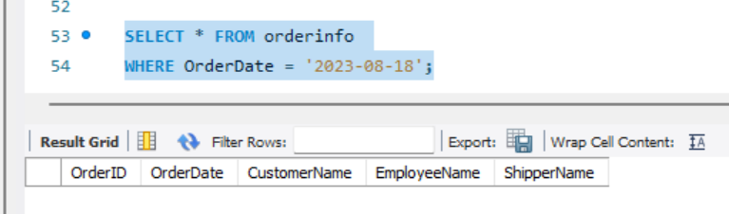

14.List countries of customers that placed order on august 19 2023 from **orderinfo**

**Query:**

SELECT DISTINCT c.Country

FROM orders o

JOIN customers c ON o.CustomerID = c.CustomerID

WHERE o.OrderDate = '2023-08-19';

**Output:**

